Operating System lab assignment

A) Introduction to OS:

Basic shell commands, and shell scripting.

Commands : date, cal, echo <text>, man <command name>, ls, pwd, mkdir, cd, rmdir, cat, sort, cp, mv, rm, wc, head, tail, more, sort, pipe (|), tr, chmod [Both symbolic and absolute representations], chown, chgrp.

Shell Scripting : Write a shell script to generate the Fibonacci series

1. date:

Command : $date

Results : date command is used to display the date, time, timezone, and more.

2. cal:

Command : $cal

Results : The cal command is used to display the current month’s calendar with the date highlighted.

3. echo:

Command : echo ”Hello”

Results : The echo command is used to print text inputted on the terminal.

Observations : Even if a Quote is forgot and entered then it breaks by asking the double quote complettion.

4. man <command name>

Command : man echo

Results : The man command is used to get the informatoin and usage of a linux command

5. ls

Command : ls

Results : ls command displays all the files an ddirectories / folders present in the present working directory.

6. pwd

Command : pwd

Results : pwd displays the present working directory.

7. mkdir

Command : mkdir

Results : The mkdir command is used to create a new directory under any directory.

8. cd

Command : cd <Directory name>

Results : The cd command is used to change the current directory.

9. rmdir
Command : rmdir <Directory name>
Results : The rmdir commadn is used to remove the specied directory.

10. cat
Command : cat [Option] [FILE]
Results : The cat command is multi-purpose utility in the linux system. It can be used to create a file, display content of the file, copy the ocntent of one file to another file and more.
11. sort
Command : sort <filename>
Results : The sort command is used to sort files in alphabetical order

12. cp
Command : cp <Existing filename> <new filename>
Results : The cp command is used to copy a file or directory

13. mv
Command : mv <filename> <directory path>
Results : The mv coommand is usde to move a file or a directory from one location to another location

14. rm
Command : rm <filename>
Results : The rm command is used to remove a file.

15. wc
Command : wc <filename>
Results : The wc command is used to count the lines, words,, and characters in a file

16. head
Command : head <filename>
Results : The head command is used to display the content of a file. It displays the first 10 lines of a file.

17. tail
Command : tail <filename>
Results : The tail command is similar to the head command. The difference b/w both the commands is that is displays the last ten lines of the file content. It is useful for reading error messages.

18. more
Command : more <filename>
Results : The more command is quite simialr to the cat command, as it is used to display the file content in the same way as cat does. The only difference is, in case of larger files, the more command displays screenful output at a time.
Overvations:
ENTER KEY : To scrool down the page by line
Space bar : To move to the next page
b Key : To move to the previous page
/ key : To search the string

19. sort
Command : sort <filename>
Results : The sort command is used to sort the files in alphabetical order

20. pipe (|)
Command : cate <filename> | tac | cat (or)
command | grep <searchWord>
Results : The grep is most is most powerful and used filter in a linux system. The grep stands for “Global regular expression print” It is useful for searching content from a file. Generally, it is used with the pipe. Or To filter a file, it is used with cat command.

21. tr
Command : command | tr <’old’> <’new’>
Results : The tr command is used to translate the file content like from lower case to upper case.

22. chmod
Command : chmod options permissions file name
Results : chmod modifies th permissions of the file specified by filename to the persmissions specified by permissions.
23. chown
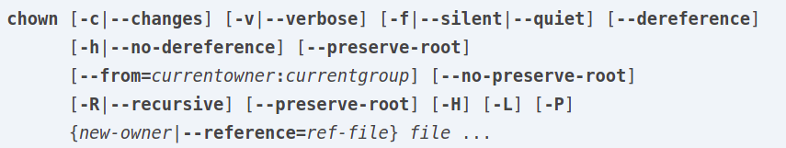
Command :
Results : chown command is used when the file’s user or group permissions to apply to a different user or group.

24. chgrp
Command : chgrp [Option] ... GROUP FILE ...
Results : The chgrp command changes the group of each file to group. If the reference options is specified, chgrp changes the group of each file to that of RFILE.

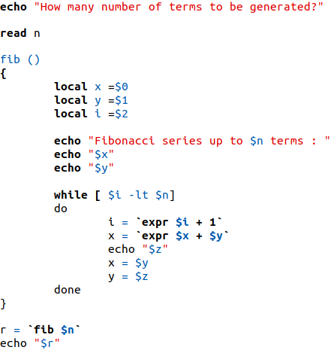
25.

PART -B: Process Basics

TASK -1:

a) ps:
Command : ps [Options]
Results : The ps is a utility provided by linux which describes us the current running process information.
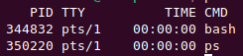

b) pstree:
Command : pstree
Results : pstree is a Linux command that shows the running processes as a tree. It is used as a more visual alternative to the ps command.

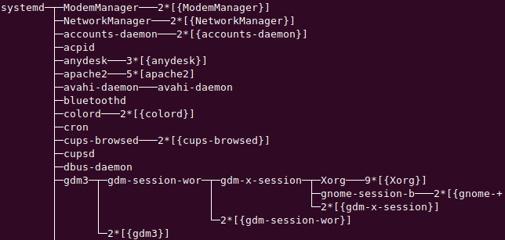

c) top:
Command : top
Results : shows the summary information of the system and the list of processes or threads which are currently managed by the Linux Kernel.
Observations:
- PID: Shows task’s unique process id.
- PR: Stands for priority of the task.
- SHR: Represents the amount of shared memory used by a task.
- VIRT: Total virtual memory used by the task.
- USER: User name of owner of task.
- %CPU: Represents the CPU usage.
- TIME+: CPU Time, the same as ‘TIME’, but reflecting more granularity through hundredths of a second.
- SHR: Represents the Shared Memory size (kb) used by a task.
- NI: Represents a Nice Value of task. A Negative nice value implies higher priority, and positive Nice value means lower priority.
- %MEM: Shows the Memory usage of task.

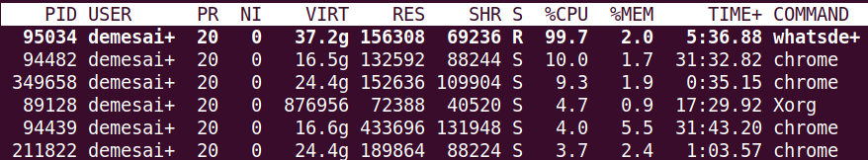
d) pgrep
Command : pgrep [-flvx] [-d delimiter] [-n|-o] [-P ppid,...] [- g pgrp,...] [-s sid,...] [-u euid,...] [-U uid,...] [-G gid,...] [-t term,...] [pattern]
Results : pgrep looks through the currently running processes and lists the process IDs which matches the selection criteria to stdout. All the criteria have to match.

e) renice
Command :renice [-n] <priority> [-p|--pid] <pid>...
Results : renice alters the priority of the running processes.
Obervations:
sudo renice -n 0 -p 1268
> 1268 (process ID) old priority 19, new priority 0
f) kill
Command : kill [-s sigspec | -n signum | -sigspec] pid
Results :It allows job IDs to be used instead of process IDs, and allows processes to be killed if the limit on processes that you can create is reached.

g) xkill
Command : xkill [-option ...] or just xkill we get x mark.
Results : Command xkill is used to kill a process on X server without passing process name or PID, xkill instructs X server to terminate client. We can see the x clients in the linux system by xlsclient command.

Task -2:
Write a simple C program that creates a process using the fork() call. Use the getpid() and getppid()
calls to print the child and parent id in created child process, and return value of fork call in parent
process.

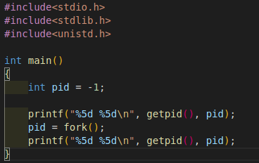

Output:
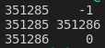

Task-3:
Write a simple C program to create a process using the exec() call. What is the difference between
a fork() and an exec() call?

